Kanha Bird Survey

# Cover Page

# Title Page

# Preface

# Introduction

# Goals

# Methods

# Results

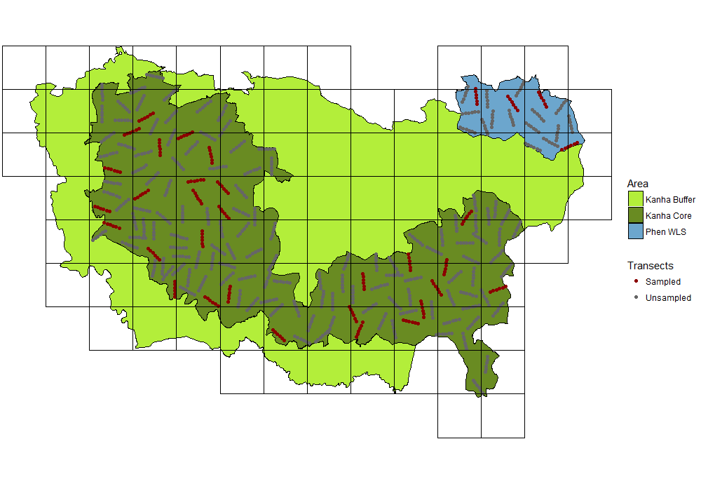

**Fig 1.** Map of survey area. The survey area was gridded and transects were selected in each grid. Each point in the map is a 200m segment of a transect. The red points represent sampled segments.

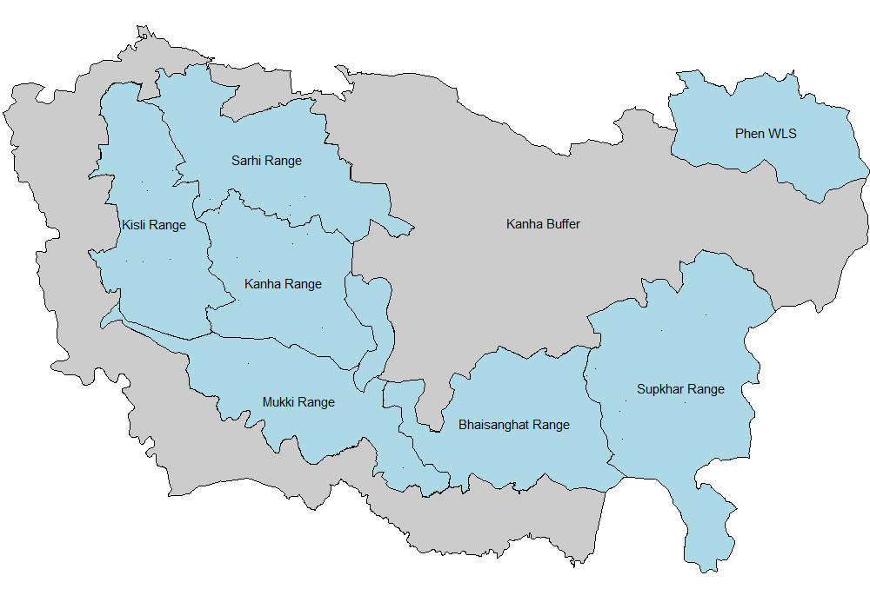

**Fig 2.** Map of ranges surveyed. Areas in blue indicate the surveyed area: the 6 ranges in Kanha WLS and Phen WLS. The area in grey is the Kanha buffer which was not surveyed.

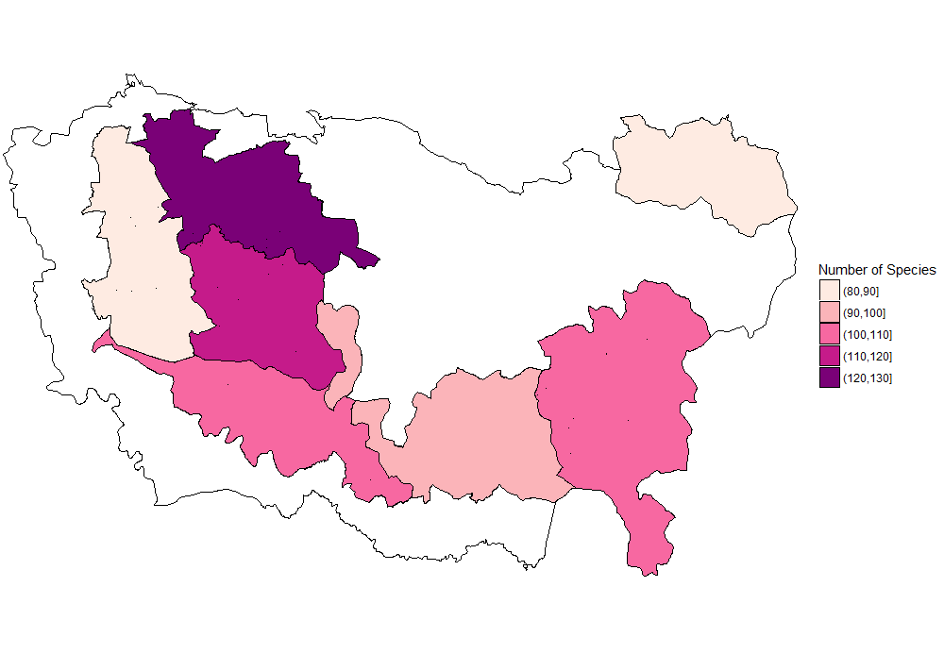

**Fig 3.** Species richness of ranges surveyed. Richness is calculated as the number of distinct species recorded in each range during the survey.

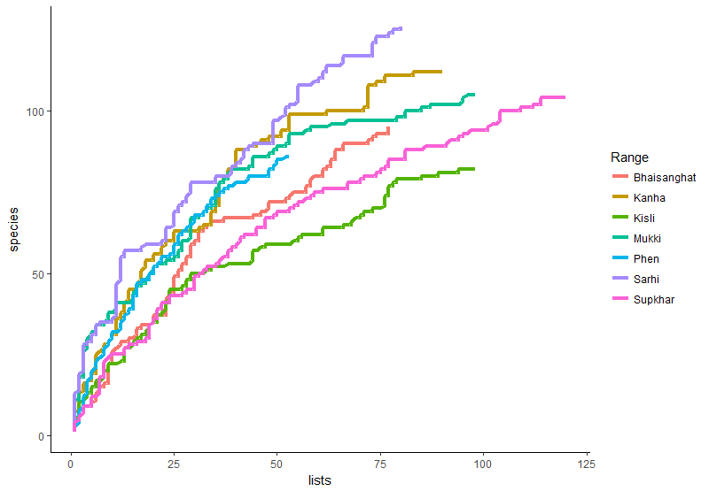

**Fig 4.** The plot shows species accumulation curves for each range. Lines trace the number of new species added for every new list in each range.

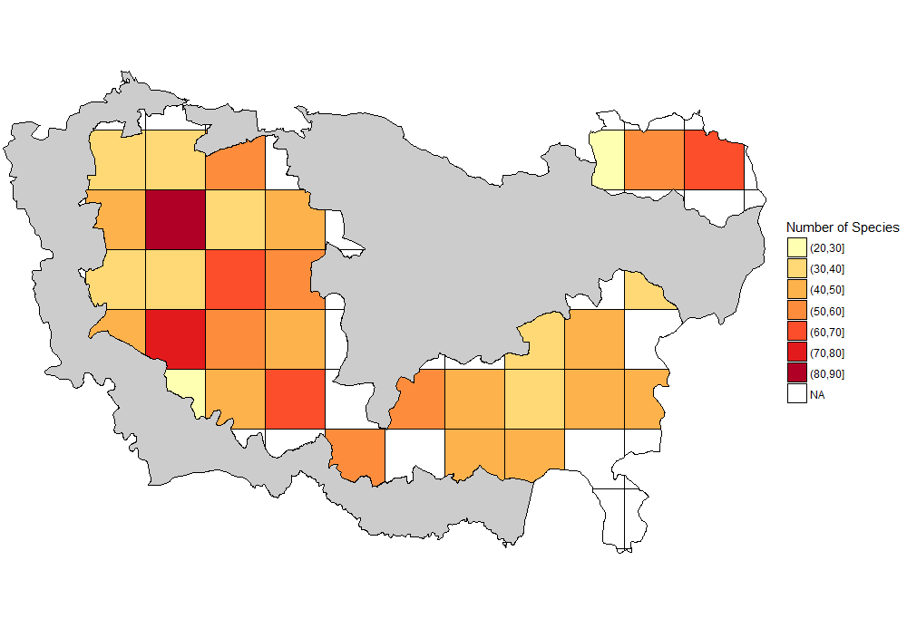

**Fig 5.** Species richness of each grid surveyed. Richness is calculated as the number of distinct species recorded in surveys in segments in the grid. White grids had no segments surveyed in them.

### Species frequencies

#### Table 1. The twenty most commonly encountered species during the survey across the entire survey area. The frequency is calculated as the proportion of the segments the species was encountered of all segments sampled.

|  |  |
| --- | --- |
| **Species** | **Frequency (%)** |
| Brown-headed Barbet (Large Green Barbet) | 60.1 |
| Plum-headed Parakeet | 37.0 |
| Rufous Treepie | 33.6 |
| Black-hooded Oriole | 26.6 |
| Purple Sunbird | 25.0 |
| Coppersmith Barbet | 22.6 |
| Greater Racket-tailed Drongo | 21.4 |
| Red-vented Bulbul | 21.3 |
| Rose-ringed Parakeet | 16.4 |
| Common Tailorbird | 15.4 |
| Large Cuckooshrike | 14.0 |
| Alexandrine Parakeet | 13.8 |
| Oriental White-eye | 13.6 |
| White-bellied Drongo | 13.1 |
| Greenish Warbler | 12.2 |
| Cinereous Tit (Great Tit) | 12.0 |
| Brown-cheeked Fulvetta | 11.4 |
| Indian Peafowl | 11.2 |
| Chestnut-shouldered Petronia (Yellow-throated Sparrow) | 10.9 |
| Jungle Babbler | 10.9 |

#### 

**Table 2.** Twenty most commonly encountered species across all grids surveyed. The frequency is calculated as the mean of encounter rates of a species from each grid.

|  |  |
| --- | --- |
| **Species** | **Frequency (%)** |
| Brown-headed Barbet (Large Green Barbet) | 59.3 |
| Plum-headed Parakeet | 36.9 |
| Rufous Treepie | 33.3 |
| Black-hooded Oriole | 26.3 |
| Purple Sunbird | 25.7 |
| Coppersmith Barbet | 22.4 |
| Red-vented Bulbul | 21.4 |
| Greater Racket-tailed Drongo | 20.9 |
| Rose-ringed Parakeet | 15.8 |
| Common Tailorbird | 15.0 |
| Oriental White-eye | 14.0 |
| Large Cuckooshrike | 13.7 |
| Alexandrine Parakeet | 13.4 |
| White-bellied Drongo | 12.7 |
| Greenish Warbler | 12.3 |
| Brown-cheeked Fulvetta | 12.1 |
| Cinereous Tit (Great Tit) | 11.7 |
| Indian Peafowl | 11.4 |
| Chestnut-shouldered Petronia (Yellow-throated Sparrow) | 10.6 |
| Jungle Babbler | 10.5 |

### 

#### Table 3. The twenty most encountered species during the survey: overall, as well as by range.

#### 

|  |  |  |  |  |  |  |  |  |
| --- | --- | --- | --- | --- | --- | --- | --- | --- |
| Rank | Overall | Bhaisanghat | Kanha | Kisli | Mukki | Phen | Sarhi | Supkhar |
| 1 | Brown-headed Barbet (Large Green Barbet) | Brown-headed Barbet (Large Green Barbet) | Brown-headed Barbet (Large Green Barbet) | Brown-headed Barbet (Large Green Barbet) | Brown-headed Barbet (Large Green Barbet) | Cinereous Tit (Great Tit) | Plum-headed Parakeet | Brown-headed Barbet (Large Green Barbet) |
| 2 | Plum-headed Parakeet | Red-vented Bulbul | Coppersmith Barbet | Rufous Treepie | Rufous Treepie | White-bellied Drongo | Brown-headed Barbet (Large Green Barbet) | Plum-headed Parakeet |
| 3 | Rufous Treepie | Plum-headed Parakeet | Plum-headed Parakeet | Plum-headed Parakeet | Black-hooded Oriole | Chestnut-shouldered Petronia (Yellow-throated Sparrow) | Rose-ringed Parakeet | Rufous Treepie |
| 4 | Black-hooded Oriole | Purple Sunbird | Purple Sunbird | Black-hooded Oriole | Plum-headed Parakeet | Black-hooded Oriole | Black-hooded Oriole | Greater Racket-tailed Drongo |
| 5 | Purple Sunbird | Rufous Treepie | Indian Peafowl | Purple Sunbird | Greater Racket-tailed Drongo | Indian Nuthatch | Indian Roller | Cinereous Tit (Great Tit) |
| 6 | Coppersmith Barbet | Coppersmith Barbet | Black-hooded Oriole | Common Tailorbird | Large Cuckooshrike | White-naped Woodpecker | Jungle Babbler | Purple Sunbird |
| 7 | Greater Racket-tailed Drongo | Spotted Dove | Greenish Warbler | Large Cuckooshrike | Red-vented Bulbul | Greater Racket-tailed Drongo | Alexandrine Parakeet | Oriental White-eye |
| 8 | Red-vented Bulbul | Large Cuckooshrike | Rufous Treepie | Greater Coucal | Common Hawk-Cuckoo | Grey-breasted Prinia | Spotted Dove | Black-hooded Oriole |
| 9 | Rose-ringed Parakeet | Rose-ringed Parakeet | Large-billed Crow | Alexandrine Parakeet | Greater Coucal | Indian Roller | Black Drongo | Coppersmith Barbet |
| 10 | Common Tailorbird | White-bellied Drongo | Rose-ringed Parakeet | Coppersmith Barbet | Spotted Dove | Rufous Treepie | Purple Sunbird | White-bellied Drongo |
| 11 | Large Cuckooshrike | Chestnut-shouldered Petronia (Yellow-throated Sparrow) | Greater Racket-tailed Drongo | Jungle Owlet | Black-rumped Flameback (Lesser Goldenbacked Woodpecker) | Rose-ringed Parakeet | Greater Racket-tailed Drongo | Red-vented Bulbul |
| 12 | Alexandrine Parakeet | Common Iora | Alexandrine Parakeet | Rose-ringed Parakeet | Brown-cheeked Fulvetta | Brown-headed Barbet (Large Green Barbet) | Greenish Warbler | Common Tailorbird |
| 13 | Oriental White-eye | Green Bee-eater | Indian Scimitar-Babbler | Black-rumped Flameback (Lesser Goldenbacked Woodpecker) | Purple Sunbird | Large Cuckooshrike | Oriental White-eye | Common Iora |
| 14 | White-bellied Drongo | Indian Peafowl | Yellow-footed Pigeon (Yellow-footed Green-Pigeon) | Greater Racket-tailed Drongo | Common Tailorbird | Red-vented Bulbul | Green Bee-eater | Hume’s Warbler |
| 15 | Greenish Warbler | Indian Tit (Indian Yellow Tit) | Oriental White-eye | Red Junglefowl | Coppersmith Barbet | Scarlet Minivet | Large-billed Crow | Alexandrine Parakeet |
| 16 | Cinereous Tit (Great Tit) | Oriental White-eye | Tickell’s Blue-Flycatcher | Greenish Warbler | Jungle Owlet | Asian Brown Flycatcher | Red-vented Bulbul | Velvet-fronted Nuthatch |
| 17 | Brown-cheeked Fulvetta | Black Drongo | Brown-cheeked Fulvetta | Large-billed Crow | Yellow-footed Pigeon (Yellow-footed Green-Pigeon) | Common Tailorbird | Common Myna | Brown-cheeked Fulvetta |
| 18 | Indian Peafowl | Common Hawk-Cuckoo | Red Junglefowl | Oriental Turtle-Dove | Chestnut-shouldered Petronia (Yellow-throated Sparrow) | Common Woodshrike | Common Tailorbird | Indian Peafowl |
| 19 | Jungle Babbler | Black-hooded Oriole | Black Drongo | Chestnut-shouldered Petronia (Yellow-throated Sparrow) | Indian Scimitar-Babbler | Coppersmith Barbet | Coppersmith Barbet | Grey-headed Canary-Flycatcher |
| 20 | Chestnut-shouldered Petronia (Yellow-throated Sparrow) | Scarlet Minivet | Red-vented Bulbul | Cinereous Tit (Great Tit) | Oriental Turtle-Dove | Jungle Babbler | Brown-cheeked Fulvetta | Jungle Babbler |

#### 

**Table 4.** Twenty most commonly encountered species overall in comparison with their encounter rate ranks in each range.

|  |  |  |  |  |  |  |  |  |
| --- | --- | --- | --- | --- | --- | --- | --- | --- |
| **Species** | **Frequency(%)** | **Bhaisanghat** | **Kanha** | **Kisli** | **Mukki** | **Sarhi** | **Supkhar** | **Phen** |
| Brown-headed Barbet (Large Green Barbet) | 60.1 | 1 | 1 | 1 | 1 | 2 | 1 | 12 |
| Plum-headed Parakeet | 37.0 | 3 | 3 | 3 | 4 | 1 | 2 |  |
| Rufous Treepie | 33.6 | 5 | 8 | 2 | 2 |  | 3 | 10 |
| Black-hooded Oriole | 26.6 | 19 | 6 | 4 | 3 | 4 | 8 | 4 |
| Purple Sunbird | 25.0 | 4 | 4 | 5 | 13 | 10 | 6 |  |
| Coppersmith Barbet | 22.6 | 6 | 2 | 10 | 15 | 19 | 9 | 19 |
| Greater Racket-tailed Drongo | 21.4 |  | 11 | 14 | 5 | 11 | 4 | 7 |
| Red-vented Bulbul | 21.3 | 2 | 20 |  | 7 | 16 | 11 | 14 |
| Rose-ringed Parakeet | 16.4 | 9 | 10 | 12 |  | 3 |  | 11 |
| Common Tailorbird | 15.4 |  |  | 6 | 14 | 18 | 12 | 17 |
| Large Cuckooshrike | 14.0 | 8 |  | 7 | 6 |  |  | 13 |
| Alexandrine Parakeet | 13.8 |  | 12 | 9 |  | 7 | 15 |  |
| Oriental White-eye | 13.6 | 16 | 15 |  |  | 13 | 7 |  |
| White-bellied Drongo | 13.1 | 10 |  |  |  |  | 10 | 2 |
| Greenish Warbler | 12.2 |  | 7 | 16 |  | 12 |  |  |
| Cinereous Tit (Great Tit) | 12.0 |  |  | 20 |  |  | 5 | 1 |
| Brown-cheeked Fulvetta | 11.4 |  | 17 |  | 12 | 20 | 17 |  |
| Indian Peafowl | 11.2 | 14 | 5 |  |  |  | 18 |  |
| Chestnut-shouldered Petronia (Yellow-throated Sparrow) | 10.9 | 11 |  | 19 | 18 |  |  | 3 |
| Jungle Babbler | 10.9 |  |  |  |  | 6 | 20 | 20 |

**Table 5.** List of habitat specialists. Species below were encountered predominantly in segments of a particular habitat over segments of other habitats.

|  |  |  |
| --- | --- | --- |
| **Sal Forest** | **Mix Forest** | **Grassland** |
| Green Warbler | Black-naped Monarch | Paddyfield Pipit |
| Malabar Whistling-Thrush | Common Woodshrike | Red-wattled Lapwing |
| Purple-rumped Sunbird | Crested Treeswift |  |
| White-rumped Munia | Grey-headed Canary-Flycatcher |  |
|  | Hume’s Warbler |  |
|  | Indian Tit (Indian Yellow Tit) |  |
|  | Laughing Dove (Little Brown Dove) |  |
|  | Red-breasted Flycatcher |  |
|  | Small Minivet |  |
|  | Tickell’s Leaf Warbler |  |
|  | Velvet-fronted Nuthatch |  |
|  | White-browed Fantail |  |
|  | White-naped Woodpecker |  |
|  | Yellow-crowned Woodpecker |  |

Conclusions and recommendations

Acknowledgements

Appendices

**Appendix 1.** List of all species encountered at Kanha during the duration of the survey. Frequencies are provided only for those species encountered during transect surveys. The others are indicated as NA.

|  |  |  |  |  |
| --- | --- | --- | --- | --- |
|  | **Common Name** | **Scientific Name** | **Sampling Protocol** | **Frequency (%)** |
| 1 | Lesser Whistling-Duck | Dendrocygna javanica | Transect,Water,General | 0.3 |
| 2 | Cotton Pygmy-Goose (Cotton Teal) | Nettapus coromandelianus | Water,General | NA |
| 3 | Northern Pintail | Anas acuta | Transect | 0.2 |
| 4 | Garganey | Anas querquedula | General | NA |
| 5 | Green-winged Teal (Common Teal) | Anas crecca | Transect | 0.2 |
| 6 | Indian Peafowl | Pavo cristatus | Transect,Water,Nocturnal,General | 11.2 |
| 7 | Red Spurfowl | Galloperdix spadicea | Transect,General | 0.3 |
| 8 | Painted Spurfowl | Galloperdix lunulata | General | NA |
| 9 | Common Quail | Coturnix coturnix | Transect | 0.2 |
| 10 | Painted Francolin | Francolinus pictus | Transect,Water,General | 0.6 |
| 11 | Grey Francolin | Francolinus pondicerianus | Transect,General | 0.5 |
| 12 | Red Junglefowl | Gallus gallus | Transect,General | 9.7 |
| 13 | Little Grebe | Tachybaptus ruficollis | Water,General | NA |
| 14 | Black Stork | Ciconia nigra | Transect | 0.2 |
| 15 | Woolly-necked Stork | Ciconia episcopus | Water,General | NA |
| 16 | Lesser Adjutant | Leptoptilos javanicus | Water | NA |
| 17 | Little Cormorant | Microcarbo niger | Transect,Water,General | 0.6 |
| 18 | Indian Cormorant (Indian Shag) | Phalacrocorax fuscicollis | General | NA |
| 19 | Cinnamon Bittern | Ixobrychus cinnamomeus | General | NA |
| 20 | Grey Heron | Ardea cinerea | Transect,Water | 0.2 |
| 21 | Purple Heron | Ardea purpurea | Water | NA |
| 22 | Great Egret | Ardea alba | Transect,Water,General | 0.2 |
| 23 | Intermediate Egret | Mesophoyx intermedia | Transect,Water,General | 0.6 |
| 24 | Little Egret | Egretta garzetta | Transect,Water,General | 1.0 |
| 25 | Cattle Egret | Bubulcus ibis | Transect,Water,General | 1.3 |
| 26 | Indian Pond-Heron | Ardeola grayii | Transect,Water,General | 1.6 |
| 27 | Black-crowned Night-Heron | Nycticorax nycticorax | General | NA |
| 28 | Red-naped Ibis (Indian Black Ibis) | Pseudibis papillosa | Transect,Water,General | 0.3 |
| 29 | Osprey | Pandion haliaetus | Water,General | NA |
| 30 | Black-shouldered Kite (Black-winged Kite) | Elanus caeruleus | Transect,General | 2.4 |
| 31 | Egyptian Vulture | Neophron percnopterus | General | NA |
| 32 | Crested Honey Buzzard (Oriental Honey-buzzard) | Pernis ptilorhynchus | Transect,Water,General | 4.7 |
| 33 | Jerdon’s Baza | Aviceda jerdoni | General | NA |
| 34 | Red-headed Vulture | Sarcogyps calvus | Transect,Water,General | 0.2 |
| 35 | White-rumped Vulture | Gyps bengalensis | Transect,General | 1.6 |
| 36 | Indian Vulture (Indian Long-billed Vulture) | Gyps indicus | Transect,General | 1.3 |
| 37 | Eurasian Griffon (Griffon Vulture) | Gyps fulvus | Transect,Water | 0.3 |
| 38 | Crested Serpent-Eagle | Spilornis cheela | Transect,Water,General | 4.5 |
| 39 | Short-toed Snake-Eagle | Circaetus gallicus | Transect,Water | 0.6 |
| 40 | Crested Hawk-Eagle | Nisaetus cirrhatus | Transect,Water,General | 0.5 |
| 41 | Mountain Hawk-Eagle | Nisaetus nipalensis | General | NA |
| 42 | Rufous-bellied Eagle | Lophotriorchis kienerii | Transect | 0.3 |
| 43 | Black Eagle | Ictinaetus malaiensis | General | NA |
| 44 | Indian Spotted Eagle | Clanga hastata | Transect | 0.2 |
| 45 | Booted Eagle | Hieraaetus pennatus | Transect | 0.2 |
| 46 | Steppe Eagle | Aquila nipalensis | Transect,Water | 0.2 |
| 47 | Bonelli’s Eagle | Aquila fasciata | Transect,General | 0.2 |
| 48 | White-eyed Buzzard | Butastur teesa | Transect,Water,General | 0.6 |
| 49 | Crested Goshawk | Accipiter trivirgatus | Transect,General | 0.2 |
| 50 | Shikra | Accipiter badius | Transect,Water,General | 2.9 |
| 51 | Besra | Accipiter virgatus | Transect,General | 0.2 |
| 52 | Black Kite | Milvus migrans | General | NA |
| 53 | Grey-headed Fish-Eagle | Ichthyophaga ichthyaetus | Transect | 0.2 |
| 54 | White-breasted Waterhen | Amaurornis phoenicurus | General | NA |
| 55 | Grey-headed Swamphen (Purple Swamphen) | Porphyrio poliocephalus | General | NA |
| 56 | Eurasian Moorhen | Gallinula chloropus | Water,General | NA |
| 57 | Indian Thick-knee (Indian Stone-curlew) | Burhinus indicus | Water,Nocturnal,General | NA |
| 58 | Great Thick-knee (Great Stone-curlew) | Esacus recurvirostris | General | NA |
| 59 | Yellow-wattled Lapwing | Vanellus malabaricus | Transect,General | 0.2 |
| 60 | Red-wattled Lapwing | Vanellus indicus | Transect,Water,Nocturnal,General | 4.1 |
| 61 | Bronze-winged Jacana | Metopidius indicus | Water | NA |
| 62 | Common Snipe | Gallinago gallinago | Water,General | NA |
| 63 | Common Sandpiper | Actitis hypoleucos | Water,General | NA |
| 64 | Green Sandpiper | Tringa ochropus | Transect,Water,General | 0.2 |
| 65 | Common Greenshank | Tringa nebularia | Water | NA |
| 66 | Wood Sandpiper | Tringa glareola | Transect,Water,General | 0.2 |
| 67 | Small Buttonquail (Common Buttonquail) | Turnix sylvaticus | Transect | 0.2 |
| 68 | River Tern | Sterna aurantia | General | NA |
| 69 | Rock Pigeon (Feral Pigeon) | Columba livia | Transect,General | 0.3 |
| 70 | Oriental Turtle-Dove | Streptopelia orientalis | Transect,Water,General | 8.1 |
| 71 | Eurasian Collared-Dove | Streptopelia decaocto | Transect,Water,General | 1.9 |
| 72 | Red Collared-Dove (Red Turtle-Dove) | Streptopelia tranquebarica | Transect,General | 1.6 |
| 73 | Spotted Dove | Streptopelia chinensis | Transect,Water,General | 10.7 |
| 74 | Laughing Dove (Little Brown Dove) | Streptopelia senegalensis | Transect,General | 2.8 |
| 75 | Asian Emerald Dove | Chalcophaps indica | Transect | 0.5 |
| 76 | Orange-breasted Pigeon | Treron bicinctus | Transect | 0.3 |
| 77 | Yellow-footed Pigeon (Yellow-footed Green-Pigeon) | Treron phoenicopterus | Transect,General | 8.6 |
| 78 | Greater Coucal | Centropus sinensis | Transect,General | 9.6 |
| 79 | Sirkeer Malkoha | Taccocua leschenaultii | Transect,General | 0.3 |
| 80 | Asian Koel | Eudynamys scolopaceus | Transect,General | 0.3 |
| 81 | Banded Bay Cuckoo | Cacomantis sonneratii | Transect,General | 0.2 |
| 82 | Grey-bellied Cuckoo | Cacomantis passerinus | Transect | 0.2 |
| 83 | Common Hawk-Cuckoo | Hierococcyx varius | Transect,Water,Nocturnal,General | 9.6 |
| 84 | Indian Cuckoo | Cuculus micropterus | Transect | 0.5 |
| 85 | Indian Scops-Owl (Collared Scops-Owl) | Otus bakkamoena | General | NA |
| 86 | Oriental Scops-Owl | Otus sunia | Nocturnal,General | NA |
| 87 | Brown Fish-Owl | Ketupa zeylonensis | Transect,Nocturnal,General | 0.2 |
| 88 | Jungle Owlet | Glaucidium radiatum | Transect,Water,Nocturnal,General | 10.1 |
| 89 | Spotted Owlet | Athene brama | Transect,Nocturnal,General | 0.8 |
| 90 | Short-eared Owl | Asio flammeus | Transect | 0.2 |
| 91 | Brown Hawk-Owl | Ninox scutulata | Nocturnal,General | NA |
| 92 | Jungle Nightjar (Indian Jungle Nightjar) | Caprimulgus indicus | Transect,Nocturnal,General | 0.5 |
| 93 | Large-tailed Nightjar | Caprimulgus macrurus | Transect | 0.2 |
| 94 | Indian Nightjar | Caprimulgus asiaticus | Transect,Nocturnal,General | 0.2 |
| 95 | Savanna Nightjar | Caprimulgus affinis | Nocturnal,General | NA |
| 96 | White-rumped Needletail (White-rumped Spinetail) | Zoonavena sylvatica | General | NA |
| 97 | Alpine Swift | Apus melba | Transect,General | 1.1 |
| 98 | Little Swift (Indian House Swift) | Apus affinis | Transect,Water,General | 0.5 |
| 99 | Little Swift | Apus affinis [affinis Group] | General | NA |
| 100 | Asian Palm-Swift | Cypsiurus balasiensis | General | NA |
| 101 | Crested Treeswift | Hemiprocne coronata | Transect,Water,General | 3.4 |
| 102 | Eurasian Hoopoe | Upupa epops | Transect,General | 0.6 |
| 103 | Indian Grey Hornbill | Ocyceros birostris | Transect,General | 4.5 |
| 104 | Common Kingfisher (Small Blue Kingfisher) | Alcedo atthis | Transect,General | 0.2 |
| 105 | Blue-eared Kingfisher | Alcedo meninting | General | NA |
| 106 | Stork-billed Kingfisher | Pelargopsis capensis | Transect,General | 0.2 |
| 107 | White-throated Kingfisher | Halcyon smyrnensis | Transect,Water,General | 3.2 |
| 108 | Pied Kingfisher | Ceryle rudis | General | NA |
| 109 | Blue-bearded Bee-eater | Nyctyornis athertoni | Transect,General | 0.2 |
| 110 | Green Bee-eater | Merops orientalis | Transect,Water,General | 5.8 |
| 111 | Blue-tailed Bee-eater | Merops philippinus | Transect | 0.2 |
| 112 | Indian Roller | Coracias benghalensis | Transect,Water,General | 8.9 |
| 113 | Coppersmith Barbet | Psilopogon haemacephalus | Transect,Water,General | 22.6 |
| 114 | Brown-headed Barbet (Large Green Barbet) | Psilopogon zeylanicus | Transect,Water,Nocturnal,General | 60.1 |
| 115 | Brown-capped Pygmy Woodpecker (Indian Pygmy Woodpecker) | Dendrocopos nanus | Transect,Water,General | 3.9 |
| 116 | Yellow-crowned Woodpecker | Dendrocopos mahrattensis | Transect,General | 2.4 |
| 117 | Pale-billed Woodpecker | Campephilus guatemalensis | Transect | 0.2 |
| 118 | Lesser Yellownape | Picus chlorolophus | Transect | 0.3 |
| 119 | Streak-throated Woodpecker | Picus xanthopygaeus | Transect,General | 0.2 |
| 120 | Black-rumped Flameback (Lesser Goldenbacked Woodpecker) | Dinopium benghalense | Transect,General | 9.9 |
| 121 | Rufous Woodpecker | Micropternus brachyurus | Transect | 0.2 |
| 122 | White-naped Woodpecker | Chrysocolaptes festivus | Transect,General | 2.9 |
| 123 | Eurasian Kestrel (Common Kestrel) | Falco tinnunculus | Transect,General | 0.6 |
| 124 | Alexandrine Parakeet | Psittacula eupatria | Transect,General | 13.8 |
| 125 | Rose-ringed Parakeet | Psittacula krameri | Transect,Water,General | 16.4 |
| 126 | Plum-headed Parakeet | Psittacula cyanocephala | Transect,Water,General | 37.0 |
| 127 | Common Woodshrike | Tephrodornis pondicerianus | Transect,General | 5.4 |
| 128 | Bar-winged Flycatcher-shrike | Hemipus picatus | Transect | 0.5 |
| 129 | Common Iora | Aegithina tiphia | Transect,Water,General | 6.7 |
| 130 | Small Minivet | Pericrocotus cinnamomeus | Transect,General | 3.9 |
| 131 | Long-tailed Minivet | Pericrocotus ethologus | Transect,General | 0.2 |
| 132 | Scarlet Minivet | Pericrocotus speciosus | Transect,General | 6.5 |
| 133 | Ashy Minivet | Pericrocotus divaricatus | Transect | 0.2 |
| 134 | Rosy Minivet | Pericrocotus roseus | Transect,General | 0.3 |
| 135 | Large Cuckooshrike | Coracina macei | Transect,Water,General | 14.0 |
| 136 | Black-winged Cuckooshrike | Lalage melaschistos | Transect | 0.3 |
| 137 | Black-headed Cuckooshrike | Lalage melanoptera | Transect | 0.6 |
| 138 | Brown Shrike | Lanius cristatus | General | NA |
| 139 | Bay-backed Shrike | Lanius vittatus | General | NA |
| 140 | Long-tailed Shrike | Lanius schach | Transect,Water,General | 0.8 |
| 141 | Indian Golden Oriole | Oriolus kundoo | Transect,Water,General | 5.2 |
| 142 | Black-hooded Oriole | Oriolus xanthornus | Transect,Water,General | 26.6 |
| 143 | Black Drongo | Dicrurus macrocercus | Transect,Water,General | 8.8 |
| 144 | Ashy Drongo | Dicrurus leucophaeus | Transect,Water,General | 2.6 |
| 145 | White-bellied Drongo | Dicrurus caerulescens | Transect,Water,General | 13.1 |
| 146 | Bronzed Drongo | Dicrurus aeneus | Transect | 0.2 |
| 147 | Hair-crested Drongo (Spangled Drongo) | Dicrurus hottentottus | Transect,Water,General | 1.9 |
| 148 | Greater Racket-tailed Drongo | Dicrurus paradiseus | Transect,Water,General | 21.4 |
| 149 | Spot-breasted Fantail (White-spotted Fantail) | Rhipidura albogularis | Transect,General | 0.3 |
| 150 | White-browed Fantail | Rhipidura aureola | Transect,General | 2.1 |
| 151 | Black-naped Monarch | Hypothymis azurea | Transect,Water,General | 5.5 |
| 152 | Indian Paradise-Flycatcher | Terpsiphone paradisi | Transect,Water,General | 0.5 |
| 153 | Rufous Treepie | Dendrocitta vagabunda | Transect,Water,General | 33.6 |
| 154 | House Crow | Corvus splendens | General | NA |
| 155 | Large-billed Crow | Corvus macrorhynchos | Transect,Water,General | 10.4 |
| 156 | Rufous-tailed Lark | Ammomanes phoenicura | Transect | 0.2 |
| 157 | Ashy-crowned Sparrow-Lark (Ashy-crowned Finch-Lark) | Eremopterix griseus | Transect,General | 0.2 |
| 158 | Indian Bushlark (Red-winged Bushlark) | Mirafra erythroptera | Transect | 0.2 |
| 159 | Sykes’s Short-toed Lark | Calandrella dukhunensis | Transect | 0.2 |
| 160 | Oriental Skylark | Alauda gulgula | Transect | 0.6 |
| 161 | Dusky Crag-Martin | Ptyonoprogne concolor | Transect,General | 0.2 |
| 162 | Barn Swallow | Hirundo rustica | Transect,General | 0.2 |
| 163 | Wire-tailed Swallow | Hirundo smithii | General | NA |
| 164 | Red-rumped Swallow | Cecropis daurica | Water,General | NA |
| 165 | Streak-throated Swallow | Petrochelidon fluvicola | Transect | 0.2 |
| 166 | Grey-headed Canary-Flycatcher | Culicicapa ceylonensis | Transect | 2.9 |
| 167 | Cinereous Tit (Great Tit) | Parus cinereus | Transect,Water,General | 12.0 |
| 168 | Indian Tit (Indian Yellow Tit) | Machlolophus aplonotus | Transect,General | 4.7 |
| 169 | Indian Nuthatch | Sitta castanea | Transect,Water,General | 3.4 |
| 170 | Velvet-fronted Nuthatch | Sitta frontalis | Transect,General | 5.4 |
| 171 | Indian Spotted-Creeper | Salpornis spilonotus | Transect | 0.3 |
| 172 | Red-vented Bulbul | Pycnonotus cafer | Transect,Water,General | 21.3 |
| 173 | Red-whiskered Bulbul | Pycnonotus jocosus | Transect,General | 1.8 |
| 174 | White-browed Bulbul | Pycnonotus luteolus | Transect | 0.2 |
| 175 | Common Chiffchaff | Phylloscopus collybita | Transect | 0.3 |
| 176 | Tickell’s Leaf Warbler | Phylloscopus affinis | Transect,Water | 0.8 |
| 177 | Sulphur-bellied Warbler | Phylloscopus griseolus | Transect,General | 2.1 |
| 178 | Hume’s Warbler | Phylloscopus humei | Transect,Water,General | 3.6 |
| 179 | Green Warbler | Phylloscopus nitidus | Transect | 1.5 |
| 180 | Greenish Warbler | Phylloscopus trochiloides | Transect,Water,General | 12.2 |
| 181 | Large-billed Leaf Warbler | Phylloscopus magnirostris | Transect,General | 0.5 |
| 182 | Western Crowned Leaf Warbler | Phylloscopus occipitalis | Transect,General | 0.2 |
| 183 | Booted Warbler | Iduna caligata | Transect | 0.2 |
| 184 | Blyth’s Reed-Warbler | Acrocephalus dumetorum | Transect,General | 0.6 |
| 185 | Clamorous Reed-Warbler (Indian Great Reed-Warbler) | Acrocephalus stentoreus | Transect | 0.2 |
| 186 | Zitting Cisticola | Cisticola juncidis | Transect,Water | 1.8 |
| 187 | Common Tailorbird | Orthotomus sutorius | Transect,Water,General | 15.4 |
| 188 | Grey-breasted Prinia | Prinia hodgsonii | Transect,Water,General | 7.1 |
| 189 | Jungle Prinia | Prinia sylvatica | Transect,General | 1.1 |
| 190 | Ashy Prinia | Prinia socialis | Transect,General | 1.8 |
| 191 | Plain Prinia | Prinia inornata | Transect,General | 1.5 |
| 192 | Lesser Whitethroat | Sylvia curruca | Transect,General | 0.5 |
| 193 | Yellow-eyed Babbler | Chrysomma sinense | Transect | 0.6 |
| 194 | Oriental White-eye | Zosterops palpebrosus | Transect,Water,General | 13.6 |
| 195 | Tawny-bellied Babbler | Dumetia hyperythra | Transect,Water | 0.5 |
| 196 | Indian Scimitar-Babbler | Pomatorhinus horsfieldii | Transect,General | 8.1 |
| 197 | Puff-throated Babbler | Pellorneum ruficeps | Transect,General | 3.2 |
| 198 | Brown-cheeked Fulvetta | Alcippe poioicephala | Transect,General | 11.4 |
| 199 | Large Grey Babbler | Turdoides malcolmi | Transect | 0.3 |
| 200 | Jungle Babbler | Turdoides striata | Transect,Water,General | 10.9 |
| 201 | Asian Brown Flycatcher | Muscicapa dauurica | Transect,General | 1.6 |
| 202 | Indian Robin | Copsychus fulicatus | Transect,General | 0.5 |
| 203 | Oriental Magpie-Robin | Copsychus saularis | Transect,Water,General | 2.1 |
| 204 | White-rumped Shama | Copsychus malabaricus | Transect,Water,General | 2.9 |
| 205 | Blue-throated Flycatcher (Blue-throated Blue-Flycatcher) | Cyornis rubeculoides | Transect | 0.2 |
| 206 | Tickell’s Blue-Flycatcher | Cyornis tickelliae | Transect,Water,General | 9.7 |
| 207 | Verditer Flycatcher | Eumyias thalassinus | Transect,General | 0.5 |
| 208 | Malabar Whistling-Thrush | Myophonus horsfieldii | Transect,General | 1.6 |
| 209 | Ultramarine Flycatcher | Ficedula superciliaris | Transect | 0.6 |
| 210 | Taiga Flycatcher (Red-throated Flycatcher) | Ficedula albicilla | Transect,General | 0.6 |
| 211 | Red-breasted Flycatcher | Ficedula parva | Transect,Water,General | 3.6 |
| 212 | Black Redstart | Phoenicurus ochruros | Transect,Water,General | 0.8 |
| 213 | Blue-capped Rock-Thrush | Monticola cinclorhynchus | Transect,General | 0.5 |
| 214 | Blue Rock-Thrush | Monticola solitarius | Transect,General | 0.2 |
| 215 | Common/Stejneger’s Stonechat (Siberian/Stejneger’s Stonechat) | Saxicola maurus | Transect,Water,General | 2.6 |
| 216 | Common Stonechat (Siberian Stonechat) | Saxicola maurus [maurus Group] | General | NA |
| 217 | Pied Bushchat | Saxicola caprata | Transect,General | 0.3 |
| 218 | Orange-headed Thrush | Geokichla citrina | Transect,Water,General | 3.2 |
| 219 | Tickell’s Thrush | Turdus unicolor | Transect | 0.2 |
| 220 | Rosy Starling | Pastor roseus | Transect,General | 0.2 |
| 221 | Asian Pied Starling (Pied Myna) | Gracupica contra | Transect,General | 0.3 |
| 222 | Brahminy Starling | Sturnia pagodarum | Transect,Water,General | 0.3 |
| 223 | Chestnut-tailed Starling | Sturnia malabarica | Transect,Water,General | 3.1 |
| 224 | Common Myna | Acridotheres tristis | Transect,Water,General | 5.4 |
| 225 | Jungle Myna | Acridotheres fuscus | Transect,General | 0.3 |
| 226 | Jerdon’s Leafbird (Jerdon’s Chloropsis) | Chloropsis jerdoni | Transect,Water,General | 2.4 |
| 227 | Golden-fronted Leafbird (Golden-fronted Chloropsis) | Chloropsis aurifrons | Transect,Water,General | 4.2 |
| 228 | Thick-billed Flowerpecker | Dicaeum agile | Transect,Water,General | 4.2 |
| 229 | Pale-billed Flowerpecker | Dicaeum erythrorhynchos | Transect,General | 6.3 |
| 230 | Purple-rumped Sunbird | Leptocoma zeylonica | Transect | 2.1 |
| 231 | Purple Sunbird | Cinnyris asiaticus | Transect,Water,General | 25.0 |
| 232 | Forest Wagtail | Dendronanthus indicus | General | NA |
| 233 | Western Yellow Wagtail | Motacilla flava | General | NA |
| 234 | Grey Wagtail | Motacilla cinerea | Transect,Water,General | 0.6 |
| 235 | Richard’s Pipit | Anthus richardi | Transect | 0.2 |
| 236 | Paddyfield Pipit | Anthus rufulus | Transect,Water,General | 2.8 |
| 237 | Long-billed Pipit | Anthus similis | Transect | 0.2 |
| 238 | Tawny Pipit | Anthus campestris | Transect | 0.2 |
| 239 | Tree Pipit | Anthus trivialis | Transect,Water,General | 1.5 |
| 240 | Olive-backed Pipit | Anthus hodgsoni | Transect | 0.2 |
| 241 | Red-headed Bunting | Emberiza bruniceps | General | NA |
| 242 | Common Rosefinch | Carpodacus erythrinus | Transect,Water,General | 2.8 |
| 243 | Scarlet Finch | Haematospiza sipahi | Transect | 0.2 |
| 244 | House Sparrow | Passer domesticus | Transect,General | 0.3 |
| 245 | Chestnut-shouldered Petronia (Yellow-throated Sparrow) | Petronia xanthocollis | Transect,Water,General | 10.9 |
| 246 | Baya Weaver | Ploceus philippinus | General | NA |
| 247 | Red Avadavat | Amandava amandava | Transect,General | 0.5 |
| 248 | Indian Silverbill (White-throated Munia) | Euodice malabarica | Transect | 0.6 |
| 249 | White-rumped Munia | Lonchura striata | Transect,General | 0.6 |
| 250 | Scaly-breasted Munia (Spotted Munia) | Lonchura punctulata | Transect,General | 0.3 |

**Appendix 2.** Distribution maps of the twenty most common species.

